**Recommendation System and Analysis**

Data File – Provided with the problem statement. 1) List of products along with pricing 2) Transaction File

Inputs: Added Ratings Column in the Transaction data set

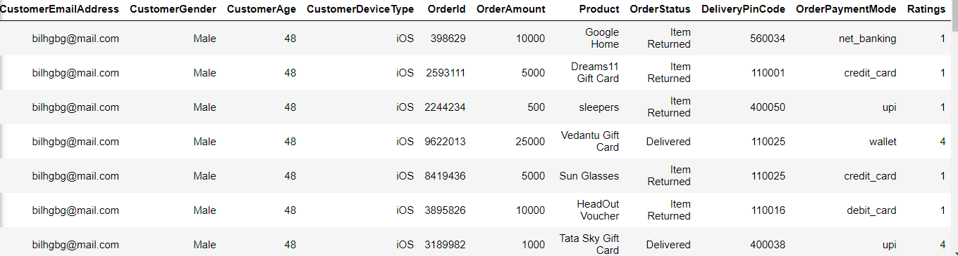

Ratings column was created on the basis of the Order status. Below is the table describing the ratings

|  |  |
| --- | --- |
| OrderStatus | Ratings |
| Item Returned | 1 |
| Delivered | 4 |
| Payment Incomplete | 2 |
| Order Cancelled | 3 |

**Exploratory Data Analysis**

Total number of Users: 100000

Total number of products is: 79

**Description of the Rating column that I have created.**

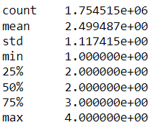

The range of rating is [1,4] with a median of 2. The mean is more than median which means that there could be slight skewness on the right. There might be few outliers on the right.

Below are the Distribution charts.

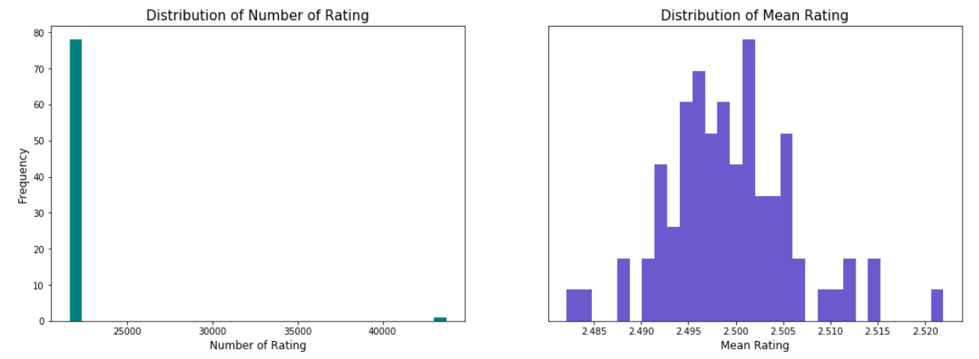

Mean Ratings chart.

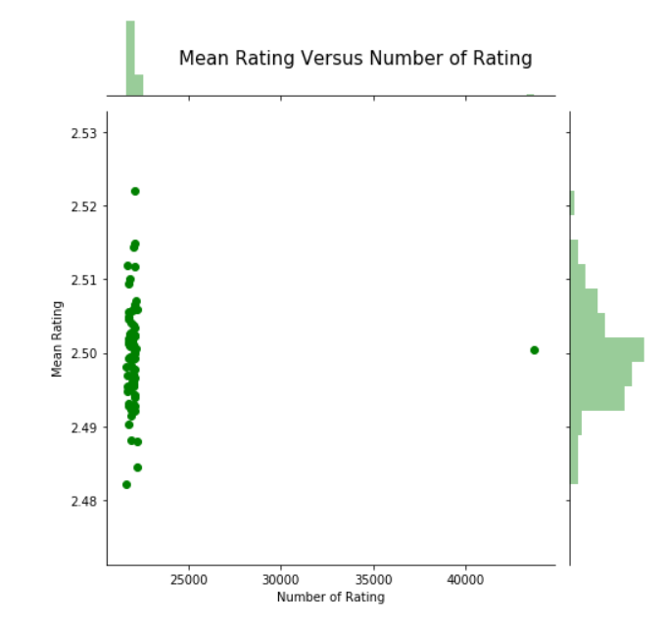

Spread of Ratings.

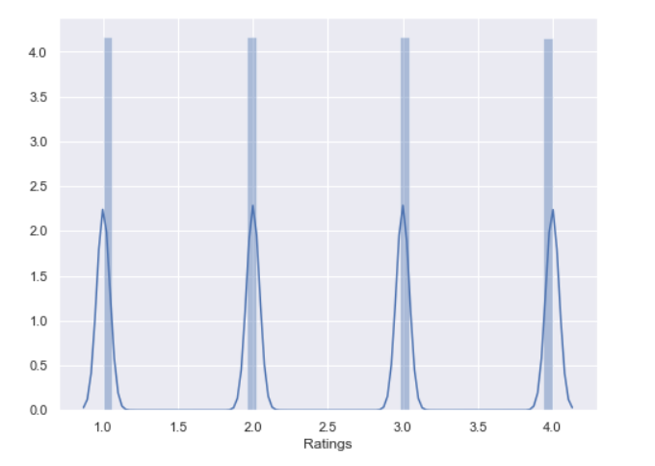

Count of ratings given by some of the Customers

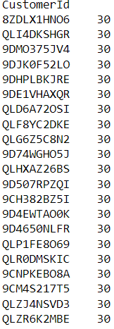

Rating count for each product

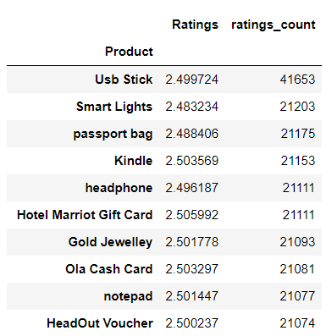

**Popularity based Recommender System**

The implementation of Popularity-Based Filtering is straightforward. All I have done is sorting our products based on ratings, and display the top products of our list. Therefore, I created the following.

* Create a metric to score or rate the products.
* Calculate the score for every product.
* Sort the scores and recommend the best rated product to the users.

I have used IMDB's weighted rating formula to score the products, as follows:

Weighted Rating (WR) = (vv+m.R)+(mv+m.C)(vv+m.R)+(mv+m.C)

* v: the number of votes for the product
* m: the minimum votes required to be listed in the chart
* R: the average rating of the product
* C: the mean vote across the whole report

Following is the result of the top Products and its score.

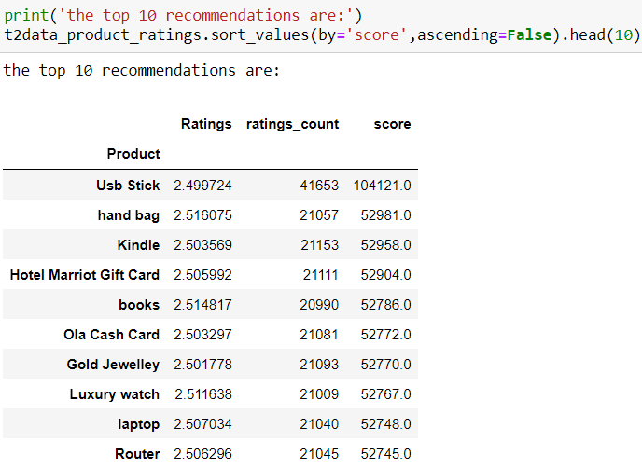

**Collaborative Filtering model**

Collaborative filtering is commonly used for recommender systems. These techniques aim to fill in the missing entries of a user-item association matrix. We are going to use collaborative filtering (CF) approach. CF is based on the idea that the best recommendations come from people who have similar tastes. In other words, it uses historical item ratings of like-minded people to predict how someone would rate an item.

Below is the RSME Score.

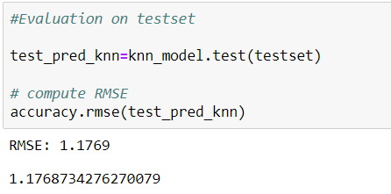

Below is the Prediction result for few data points.

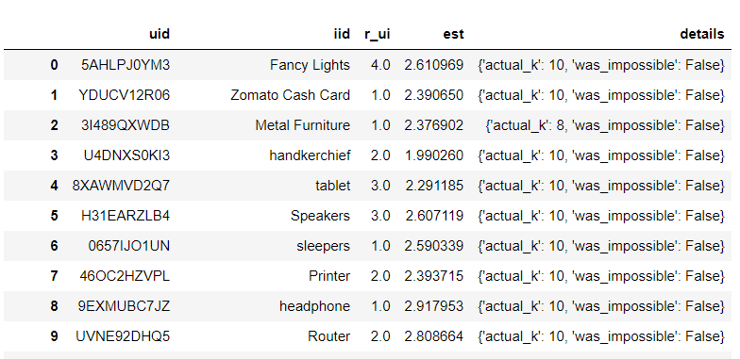

Let’s see the top 5 values of one the customers.

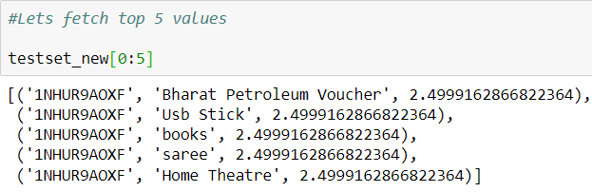

Now let’s see the top 5 recommendation for each customer. Below is the example for only few users.

